**Program no____3_____**

**Program Title______LED FADING___________**

**Aim The light Fades in and Fades out according to the delay**

**Hardware Required**

* Arduino Board

LED

**Circuit Diagram**

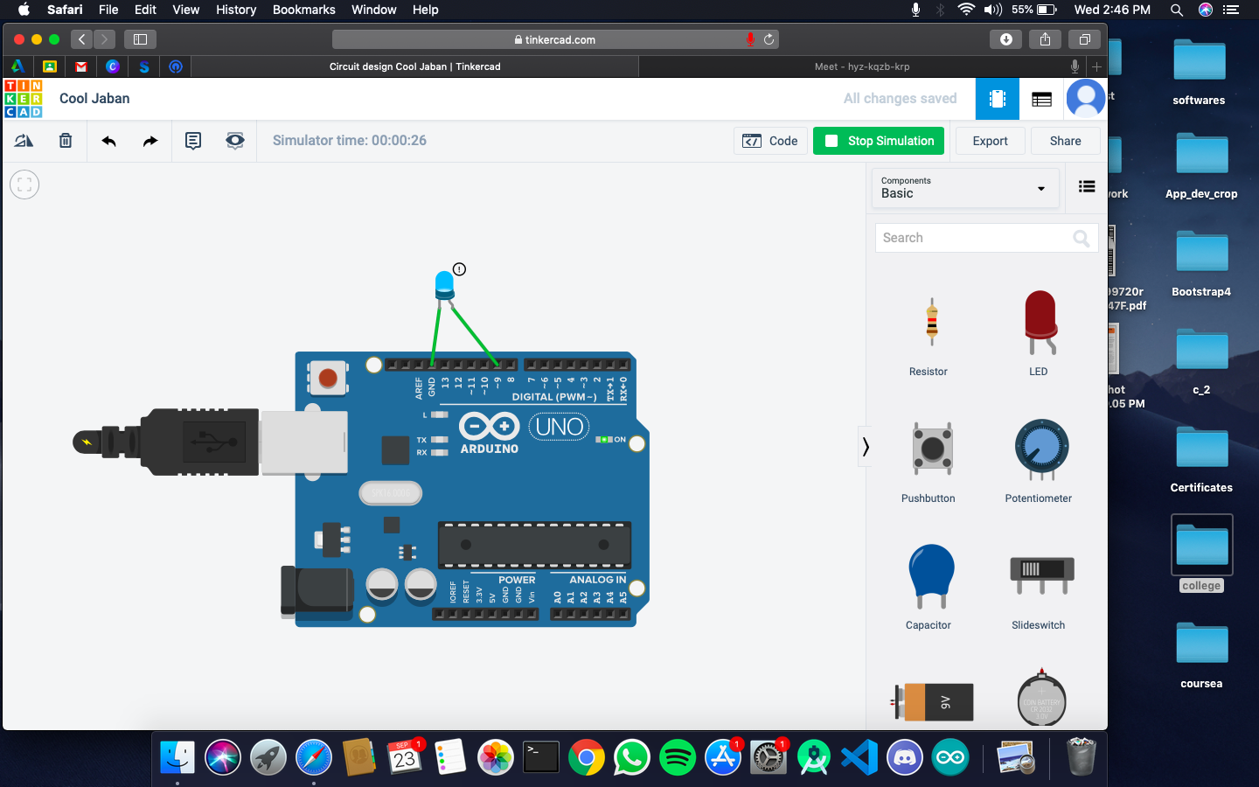

**Code:**

int ledpin=9;

void setup() {

// put your setup code here, to run once:

}

void loop() {

// put your main code here, to run repeatedly:

for(int fadevalue=0;fadevalue<=255;fadevalue+=5){

analogWrite(ledpin,fadevalue);

delay(40);}

for(int fadevalue=255;fadevalue>=0;fadevalue-=5){

analogWrite(ledpin,fadevalue);

delay(40);}

}

**Observation /Output**

**the lights fades in and fades out according to the delay**